Research Summary
Integrated Catchment Management and
Planning for Sustainability -
The Case of the Mersey Basin Campaign

Joanne Tippett
School of Planning and Landscape, University of Manchester

November 14, 2001

Context 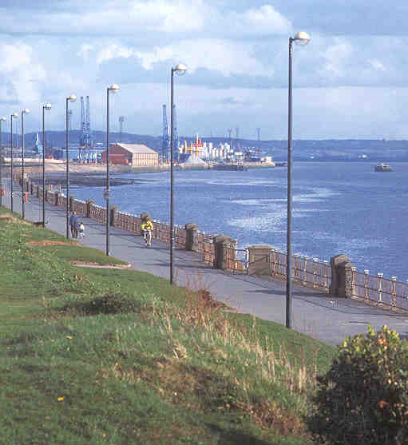
It has become clear over the last two decades that effective water management can only occur when all of the problems that can affect water quality are addressed. Symptoms of water-related problems are often detected far from their sources. Efforts to improve the water environment are impeded by multiple authorities not working together and a lack of effective links between local actions and catchment-wide planning.
This research examined 'planning for sustainability' in river catchment management, with the Mersey Basin Campaign as the principal case study. The newly enacted European Union Water Framework Directive requires each Member State to produce an integrated management plan for every river basin. These plans must be formulated with a high degree of community and stakeholder involvement. The Mersey Basin Campaign offers a valuable case study in how to achieve this ambitious objective.

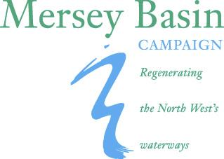 |  |  | 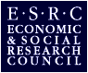 | 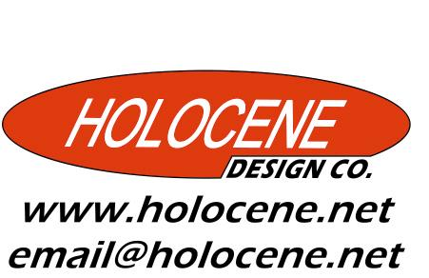

The Mersey Basin Campaign 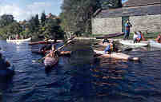
The Mersey Basin Campaign, a 25-year government initiative launched by the Department of the Environment (UK) in 1985, is seen as an important player in achieving the North West region’s objective of a ‘green and pleasant region’ (NWRA 1993). It was awarded the inaugural International RiverPrize for best practice in Catchment Management in Brisbane, Australia in 1999. This prize recognised its pioneering role in developing a stakeholder partnership for catchment-wide planning and action.
Situated in the North West of the UK, the Mersey's 2000 kilometres of waterways and canals hold significant historic value. Owing to their key role in the development of the Industrial Revolution and subsequent industrial development, they also offer a long-term case study in pollution and neglect of environmental assets. The 4,680 km² of the Basin are home to over 5 million people. The Catchment includes areas of poverty and physical dereliction, as well as outstanding natural beauty, such as the Peak District, and the cities of Manchester and Liverpool. The Mersey was once described by Michael Heseltine (then Secretary of State for the Environment “affront to civilized society” (MBC 2000, pg. 2), and at the start of the Campaign, was the most polluted river in the UK (Wood, Handley and Kidd 1997).
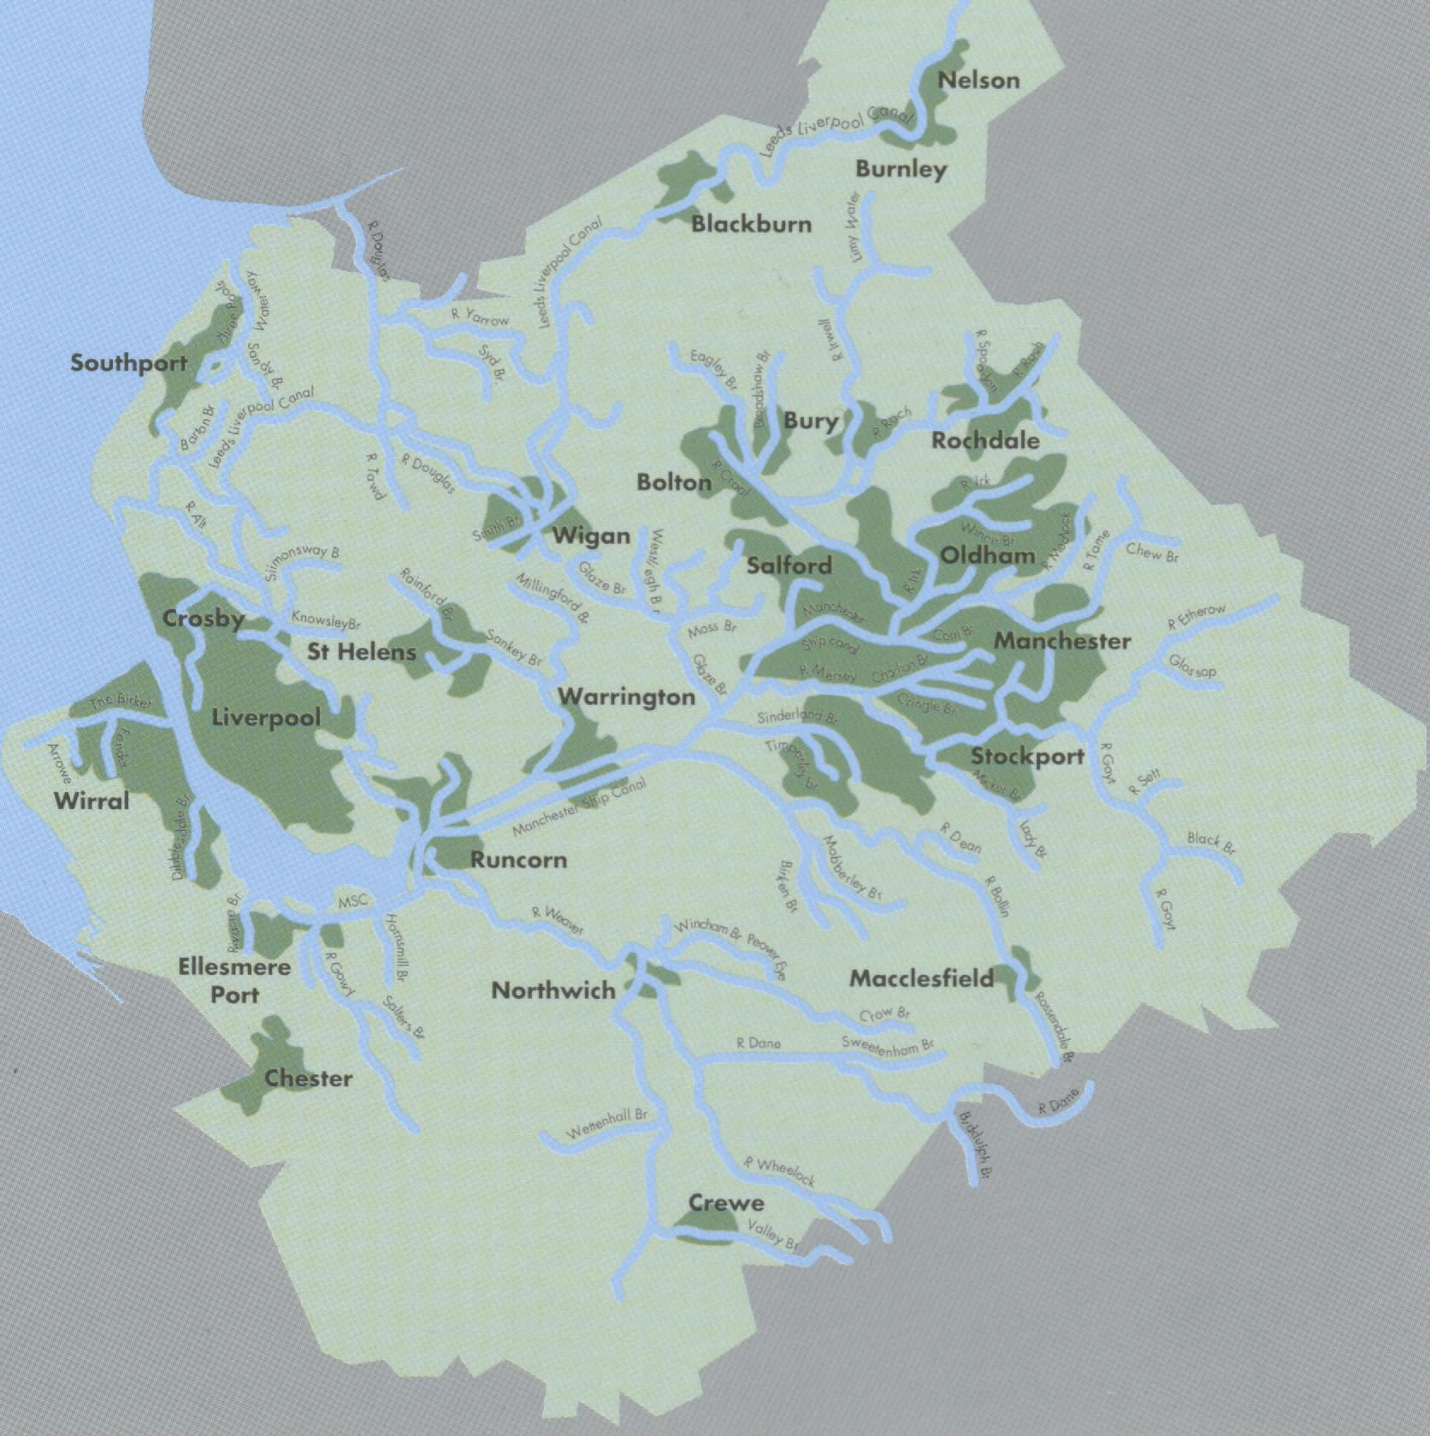
Map of the Mersey Basin Source Mid Term Report (Wood, Handley and Kidd 1997)
The Campaign's aims are:
- Water Quality: to ensure that all rivers, streams and canals are of good quality offering the cleanest possible litter free environment and diverse wildlife habitat by 2015
- Waterside Development: the Campaign partnership will operate directly and as a main strategic player to stimulate the sustainable development of attractive waterside environments – for businesses, housing, tourism, heritage, recreation and wildlife bringing benefits to the regional economy
- Awareness and Education: create and support a culture to mark out the Mersey Basin as a region of waterways in which all who live and work cherish the waterside environment, understand it, take pride in the waterways & see the improvement as leading to a better quality of life (MBC 2001b)
In order to achieve its aims, the MBC promotes basin-wide strategic planning and local initiatives for long-term enhancement of the environment. It operates as a flexible partnership, encouraging integrated work between the private sector, communities and government bodies, and has been recognised as “a model for what will become an increasing need for engaging coordinated action through a partnership approach” (Wood, Handley and Kidd 1999, pg. 342).

Research Project 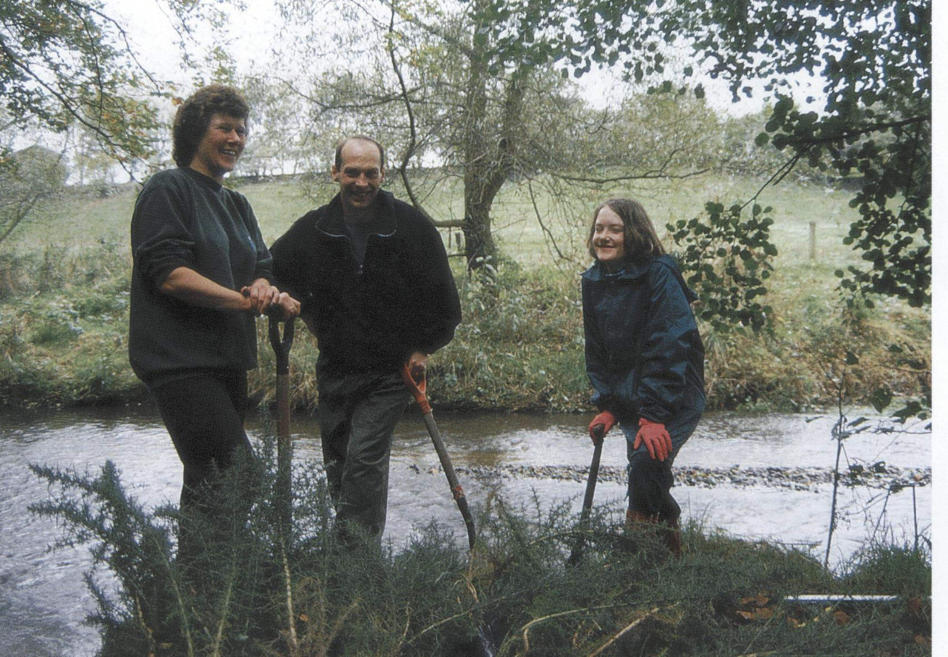
This research has examined two of the Campaign’s delivery mechanisms identified as important in previous reviews of the Campaign, partnership networking and strategic planning, linking multiple geographical scales. Interviews with 25 key players, participant observation and programme literature provided a wealth of data.
The overall research question was:
How is ‘planning for sustainability’ delivered through the processes and mechanisms of the Mersey Basin Campaign?
This posed three inter-related questions:
- What are the characteristics of communication and coordination within the Campaign that help to increase partnership and cross-sectoral working?
- How is strategic planning encouraged at multiple scales in the partnerships within MBC?
- How are sustainability principles applied in planning and projects?

Findings 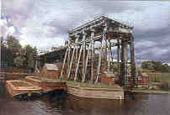
The fact that water quality in the Mersey Basin has improved dramatically since the inception of the Campaign is a testament to its success. The research findings offer lessons from the 15 years of experience of the Campaign, which can be applied to similar initiatives, as well as pointers for improving the effectiveness of the Campaign itself. The findings are in three sections:
- Analysis of the research questions
- Analysis of the nature of partnerships and cross-cutting themes
- Conclusions
  - Factors for successful Catchment-based partnerships
  - Detailed recommendations for the Campaign

These are summarised below. The full research report as well as this report can be downloaded from: www.holocene.net/research/ICM-MBC.htm

Nature of partnerships

Benefits
- partnerships produce results beyond the capabilities of the individual entities
- cost effective way of working
- increased knowledge base for strategic planning
- enhanced possibilities for integrated thinking – combination of multiple perspectives
- broad range of support for projects
- behavioural change leading to sustained action
- long lasting benefits
- allowing participants to see how particular actions fit into a larger whole
- increased learning amongst participants

Disadvantages
- the work can seem an 'extra' duty
- possible to shift responsibilities for doing work

Difficulties in setting up and maintaining a partnership
- takes time to develop
- needs continuous maintenance and attention in order to remain viable
- difficult to maintain people’s enthusiasm over a long period of time
- both the partnership and external context change over time
- timetable of development needs to be driven by participants' needs rather than by the often rigid requirements of funding deadlines
- difficult to measure the added value brought by the partnership
- benefits tend to accrue in the longer term rather than immediately
- need to give credit to partners amongst whom the responsibilities are shared

Key Elements of an Effective Partnership

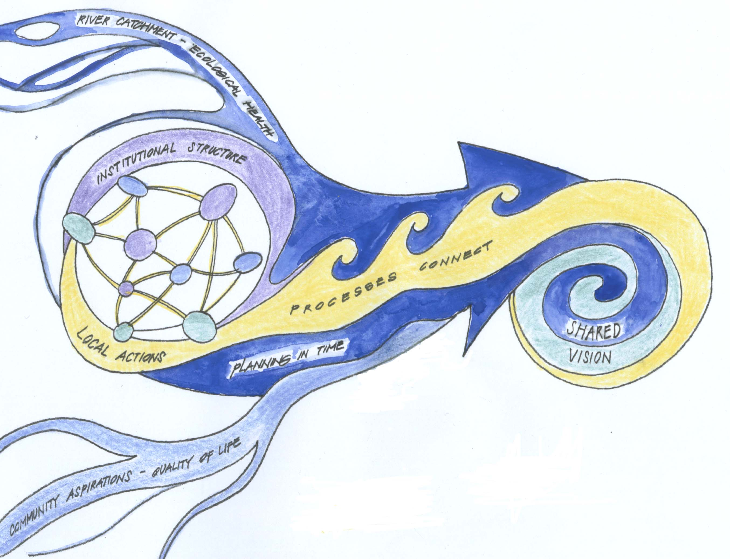
drawn by holocene design
Breakdown of Key Elements of an Effective Partnership

Vision
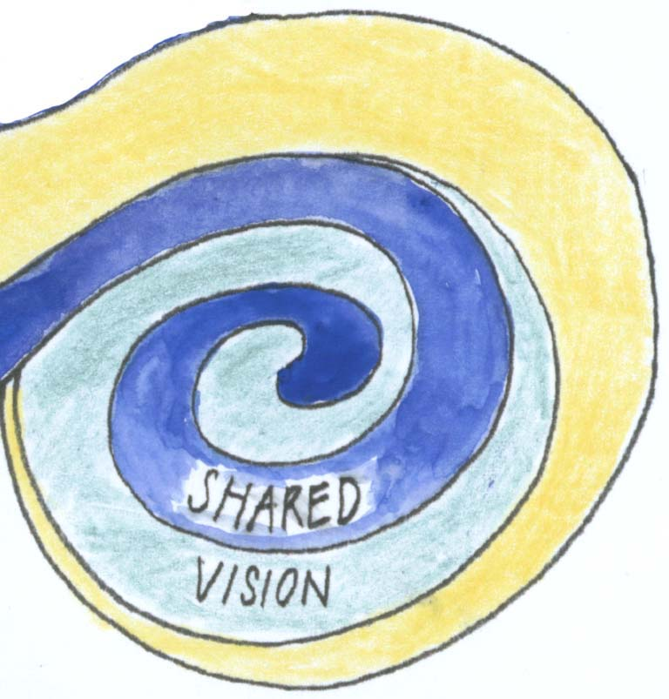 | - commonly understood and shared  - broad and ambitious goals  - ongoing development of criteria of success
Structure
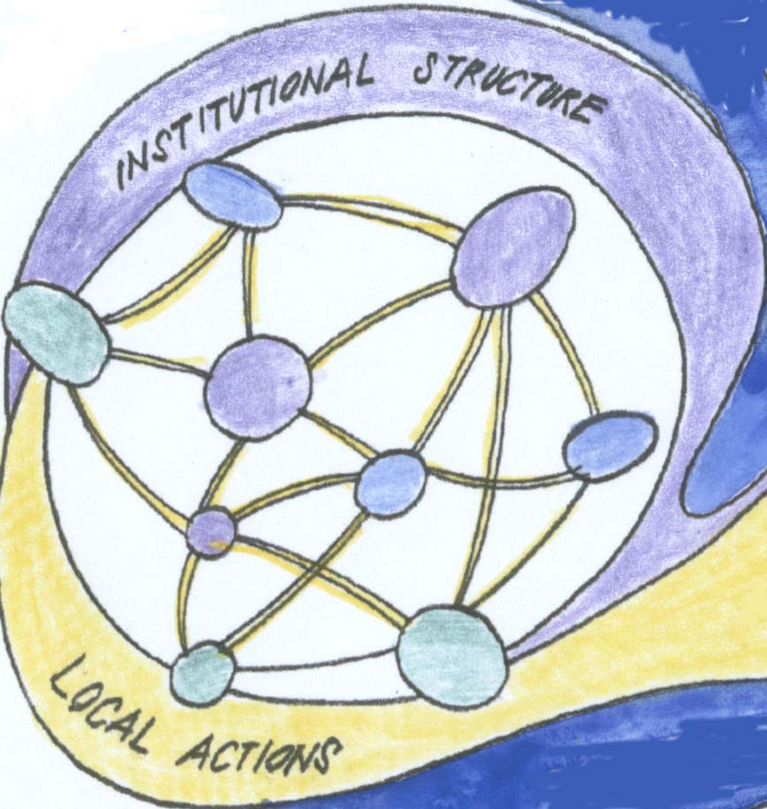 | Institutional  - umbrella for broad engagement of sectors and stakeholders  - equitable power sharing  - transparent structure and decision making processes  - oversight and assessment  - political backing and leadership  - skilled people as pivots and coordinators  - professional roles for key activities  - encourages effective local action
Key Elements of an Effective Partnership (continued)
Structure (continued)
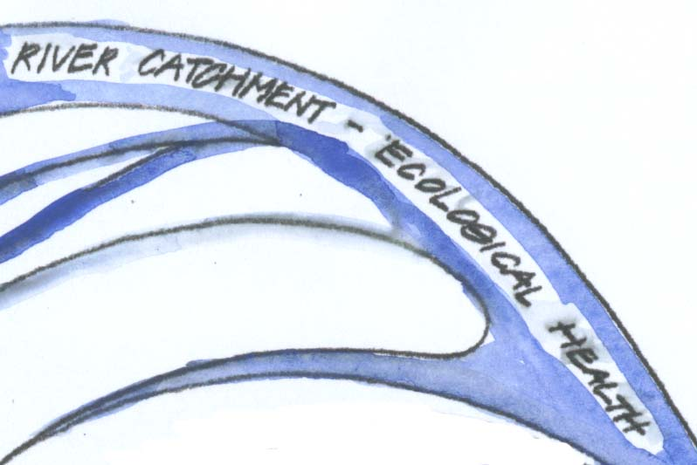 | Spatial  - river catchment as organising unit  - promote overall ecological health of catchment  - links across multiple geographic levels of scale, working simultaneously at the local and catchment-wide levels  - connects communities of interest
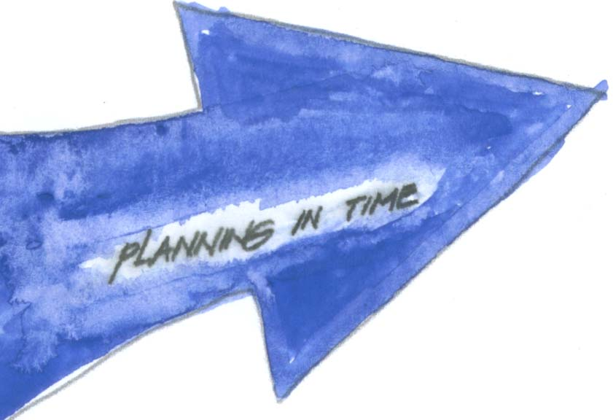 | Temporal  - stages of strategic planning and innovation  - stages of assessment and review  - conscious attention to planning opportunities for both formal and informal interactions  - build support for long-term planning through on-going, achievable projects
Process
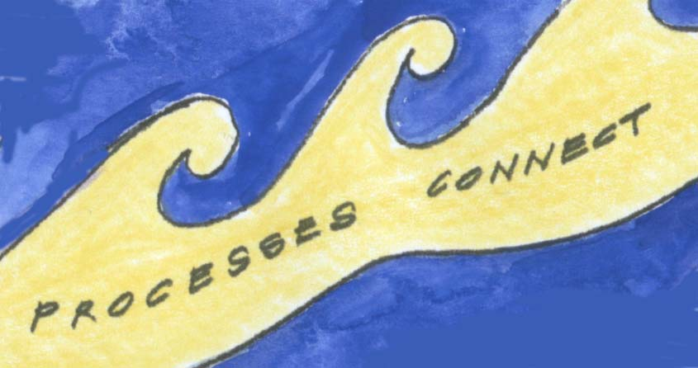 | - continuous, dynamic development (adaptive capacity)  - investment of time and attention  - skills development and capacity building at all levels  - working to achieve synergistic added value  - multiplicity of ways of communicating and planning  - innovative approaches  - actively encourage openness and transparency
Quality of Process 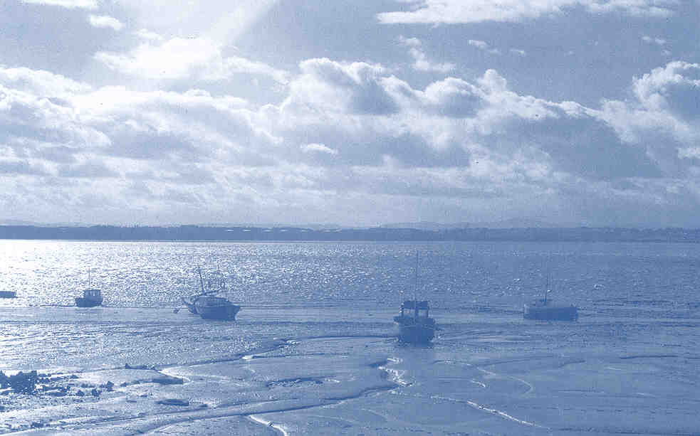
The processes involved in creating and maintaining a partnership play an important role in the success of the partnership. They provide a means of connecting the organisations in the partnership, local actions and the long-term vision. The difficulties encountered in developing a partnership can be better understood through an exploration of dualities and tensions inherent in a complex endeavour. Four key dualities that emerged from this analysis were:
- Importance of personalities and the need for systematic processes
- The need for meaningful participation and the pressure of limited time
- The need for long-term strategic planning and the pressure to meet short term targets
- The pressure for success stories and the possible danger of 'end of pipe' solutions
There is a tension between the all-important building of relationships in a partnership and the need to systematize the networking process, so that the skills and knowledge vested in individuals is not lost to the partnership as those individuals change roles or leave the partnership. Whilst the benefits of increased participation in decision making are manifold, engaging meaningful participation is a time consuming process, and the benefits of this process tend to accrue in the long-term, which is problematic in a climate of increasing pressure for easily measurable short-term indicators of success. In some ways, the Campaign could be seen as a victim of its own success. Water quality improvements have been dramatic. The next phase of improvements, however, will involve behavioural change amongst a very broad range of water and land users, ranging from SMEs to householders to farmers, as well as a profound redesign of energy and material flows in sectors as diverse as: housing, agriculture, transport and industrial systems.
Many of the characteristics of a partnership can be both weaknesses and strengths. A focus on the quality of the processes that constitute the building of relationships in a partnership and an awareness of the context of those processes can help to ensure that these dualities are used as drivers of innovation, rather than act as detriments to the partnership. In a River Catchment Partnership such as the Mersey Basin Campaign, these processes can be broken down into three main areas: Partnership Development; Strategic Planning and Coordination and Collaborative Planning and Organisational Learning. Important characteristics of these processes that emerged from this research are summarised below.

Characteristics of Process Quality

Partnership Development

- actively seek partners and broaden network
- ensure equitable representation of interests
- encourage involvement in decision making
- non judgemental, providing a neutral environment
- pay conscious attention to quality and clarity of communication
- create time and space for partnership development
- create opportunities for informal interaction
- value work of partners

Strategic Planning and Coordination

- expanded view
  - large geographic unit
  - long timescale
  - broad nature of aims
- start small with projects that lead to success stories
- maintain links between local actions and strategic aims
- synthesise bottom-up and top-down planning process
- different focuses for engaging partners in action – cross boundaries
- allow for changeable nature of networks – fluid connections in time and space

Collaborative Planning and Organisational Learning

- create opportunities for organisational learning
- horizontal skills sharing, to increase adaptability to changes in personnel and partners over time
- create opportunities for a high level of engagement in planning process
- develop effective process of collaborative planning
- co-ordinate gathering and integration of data
- facilitate broad access to data to facilitate collaborative planning
- incorporate integrated sustainability principles into planning process

Conclusion 

This research demonstrates that the processes of maintaining a partnership are key to increasing its effectiveness in planning and integration. A complex partnership has tensions and dualities, which can create problems at many times during its evolution. Collaborative planning processes can help utilise these tensions to enhance innovation and dialogue, but require continuous attention and learning of new skills by Campaign staff and partners. The fact that there is no easy way to simultaneously improve the natural and human environment should not come as a surprise.
The surprise lies in the depth of learning about processes that could help to bring about such changes, which the experience of the Mersey Basin Campaign can offer. The next ten years should prove to be a further valuable learning experience.

Acknowledgements and Further Research

The research was conducted as partial fulfilment of the requirements of an MA Econ. in Social Research. It is part of a larger research project conducted by the author entitled "A Participatory Protocol for Ecologically Informed Design Within River Catchments". This research will focus on the process of collaborative planning in the Mersey Basin Campaign, in the context of the European Union Water Framework Directive (EC 2001b). It is supported by the Mersey Basin Campaign and the Economic and Social Research Council. The Ph.D. supervisors for this project are:
Professor John Handley, Groundwork Professor of Land Restoration and Management , School of Planning and Landscape, University of Manchester
Joe Ravetz – co-ordinator of the Centre for Urban and Regional Ecology, School of Planning and Landscape, University of Manchester
Jeff Hinchliffe – Chief Executive, Mersey Basin Campaign

Further information about this project can be found at:
www.holocene.net/sustainability/MBC-research.htm 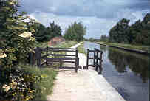
Recommendations For the Campaign 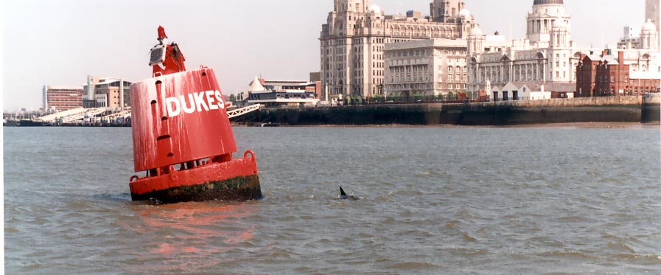
Whilst the Campaign has achieved remarkable successes in over 15 years of operation, and has developed many successful mechanisms for enhancing partnership working, this research has uncovered possible improvements to take it forward in the next 10 years. These recommendations fall under three headings:
A. Opportunities for organisational learning
B. Increasing the quantity and quality of collaborative planning processes
C. Support for RVI programmes and investing in skills training
Recommendations to expand existing programmes are particularly relevant in the light of the increased importance placed on participatory processes within the emerging sustainable development agenda and, specifically, the requirements for participation introduced by the newly enacted European Union Water Framework Directive (EUWFD) (EC 2001a). Discussions of implementing the EUWFD point to the long-term cost benefits of enhanced stakeholder participation in planning. A potential major obstacle to successful implementation is underestimating the human and financial resources required to facilitate this participation (Jones 2001, pg. 19).
Interviews with partners suggested that the input of community and voluntary sectors into the Campaign has been a hallmark of its excellence, as recognised by being awarded the International RiverPrize. A significant factor in building partnerships that emerged from the analysis was that it takes time to develop relationships and build effective networks. Changes recommended below should be made in consultation with the partnership, to ensure that they build on its unique strengths.
The recommendations for RVIs receive extra impetus from the Campaign's shift towards a greater operational focus, with an emphasis on the RVIs as a major delivery mechanism (MBC 2001a). These changes will require an expansion of existing support and training programmes. In a time when the need for skilled people to facilitate community projects and promote integrated thinking is emphasised, the Campaign can play a key role in helping to define a new "sustainability professionalism" (e.g. WWF-UK 2000; Knowland and Ali-Khan 2001).

A. Organisational learning
- Allocate designated sessions for pooling of best practise at managers meetings, RVI chair and coordinator meetings. These could include discussions with the wider Campaign staff, to bring in different areas of expertise and experience.
- Expand mechanisms for giving recognition to originators of best practice – enhancing professional development and motivation for making the information widely available.
- Enhance educational value of award schemes through case study materials and site visits (e.g. Dragonfly Awards and Business and Environment Awards).

B. Collaborative planning processes
- Include time in Council meetings for small-group discussion. This could allow opportunities for innovative input into strategic planning (not currently facilitated by the large size of the Council meeting). Discussion sessions could be facilitated to enhance effective dialogue and efficient use of time, with brief feedback to the larger group of key themes and action items raised.
- Clarify membership structure and criteria for membership on Council. Whilst the membership of the Council is broad and a list of partners on the Council is published in the Corporate Plan, enhanced communication about mechanisms for taking on new sectors and for ensuring equitable and broad representation would alleviate confusion as to the structure of the Council.
- Develop and clarify mechanisms for partners and Pledge Groups to give feedback into the Campaign planning process. This will be particularly important if there is an increase in participation in Integrated Catchment Management, as called for by the EUWFD.
- Publish organisational structure and explanation of processes for engagement in Campaign planning in easy to access form (e.g. on the web or an intranet), to increase transparency as to decision-making processes and roles.
- Develop mechanisms for synthesis of top-down and bottom-up planning, incorporating integrated science and landscape ecology. These mechanisms should build on existing structures for engaging voluntary, business and community organisations. Such a development could enhance the Campaign's position as a leader in Catchment planning. Mechanisms could include: templates for planning at multiple scales and synthesis workshops between people working at different geographical scales to discuss and agree upon goals, common themes and potential conflicts and divergences and how these may be overcome.
- Increase the resources allocated for involving communities, NGOs, SMEs and landowners in an Integrated Catchment Planning process and promote capacity building to stimulate effective participation.

C. RVI programme support and skills training
- Improve operational efficiency of RVI coordinators by providing increased fundraising and administrative support from the Campaign Centre.
- Expand existing skills training programmes. Offer increased training in: participatory facilitation skills, strategic planning, use of GIS in project planning, integrating programmes into formal Education at multiple levels and communication skills. Much of this additional training could be project based, to help RVIs achieve objectives at the same time as enhancing skills.
- Further develop capacity in the Centre to provide supplementary support for RVI projects that would otherwise be outside the scope of one RVI coordinator. This could include resources to provide assistance and extra skilled personnel for participatory planning and programme design. As the need for this support varies over time in the different RVIs, this could be an effective use of support from the Centre.

References:
EC (2001a). Strategic document, Common Strategy on the Implementation of the Water Framework Directive. Paris, Sweden, EU Water Directors, European Commission, EU Member States: 71.
EC (2001b). Water Quality in the European Union - The EU Water Framework Directive, Europa Website, European Commission. 2001.
Jones, T. (2001). Implementing the EU Water Framework Directive: A seminar series on water Organised by WWF with the support of the European Commission and TAIEX, Synthesis Note Seminar 3: Good Practice in River Basin Planning. Brussels, WWF, European Commission, TAIEX: 31.
Knowland, T. and S. Ali-Khan (2001). Sustainable Development Professionals: who needs them? EG April: 10 - 13.
MBC (2000). Mersey Basin Campaign, Progress Report 1985 - 2000, Building a Healthier Economy Through a Cleaner Environment. Manchester, Mersey Basin Campaign.
MBC (2001a). Mersey Basin Campaign, Corporate Plan 2001 - 2004. Manchester, Mersey Basin Campaign.
MBC (2001b). The Next Decade - A Summary. Manchester, Mersey Basin Campaign.
NWRA (1993). Regional Economic Strategy for North West England. Warrington, North West Regional Assembly and North West Business Leadership Team.
Watson, N. (2001). Creating Effective Partnerships for River Basin Development: An Evaluation of the Fraser Basin Council, British Columbia, Canada. Lancaster, Department of Geography, Lancaster University, Faculty Research Program of the Canadian High Commission, London and the Institute of Environmental and Natural Sciences: 31.
Wood, R., J. Handley and S. Kidd (1997). Mersey Basin Campaign - Mid Term Report - Building a healthier economy through a cleaner environment, Mersey Basin Campaign.
Wood, R., J. Handley and S. Kidd (1999). Sustainable Development and Institutional Design: The Example of the Mersey Basin Campaign. Journal of Environmental Planning and Management 42 (3): 341-345.
WWF-UK (2000). Professional Practice for Sustainable Development, Book1: Building support within the profession. Bourne, Professional Practice for Sustainable Development - Project Management Group, WWF-UK, Council for Environmental Education, The Environment Agency, The Institution of Environmental Sciences, The Natural Step, UK: 8.

Wording from Watson, N. (2001). Creating Effective Partnerships for River Basin Development: An Evaluation of the Fraser Basin Council, British Columbia, Canada. Lancaster, Department of Geography, Lancaster University, Faculty Research Program of the Canadian High Commission, London and the Institute of Environmental and Natural Sciences: 31.
"End of pipe" solutions to environmental problems tend to focus on ways of reducing discharge into sensitive environments, such as filters, as opposed to attempting to pre-empt the problem through redesign of the production process at source.
SME – Small to Medium Enterprise.
Planning in the sense of projects and strategic plans, not statuary planning.
NGO – Non Governmental Organisation
SME - Small to Medium Enterprise

